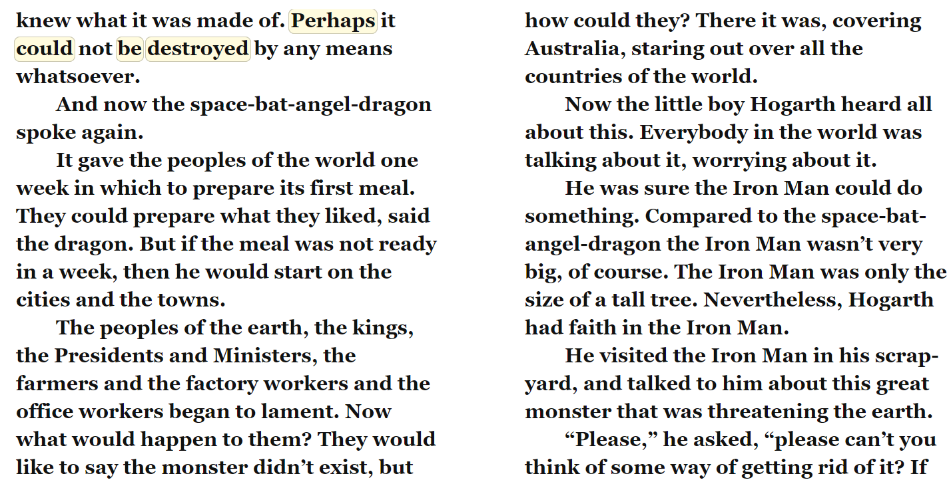

- It says in the text, “the peoples of the earth began to lament”. What do you think this word means? Can you work it out from the clues in the text?

- Why do you think that Hogarth has faith’ in the Iron Man?

- What do you think the Iron Man is going to do and why?

