Tuesday 2nd February 2021

Pun Headline
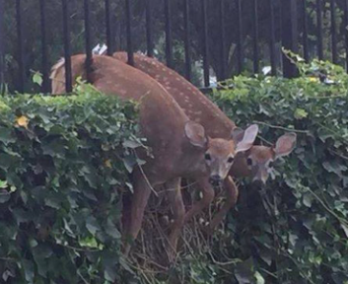

Alliteration Headline
My chosen sport is...

