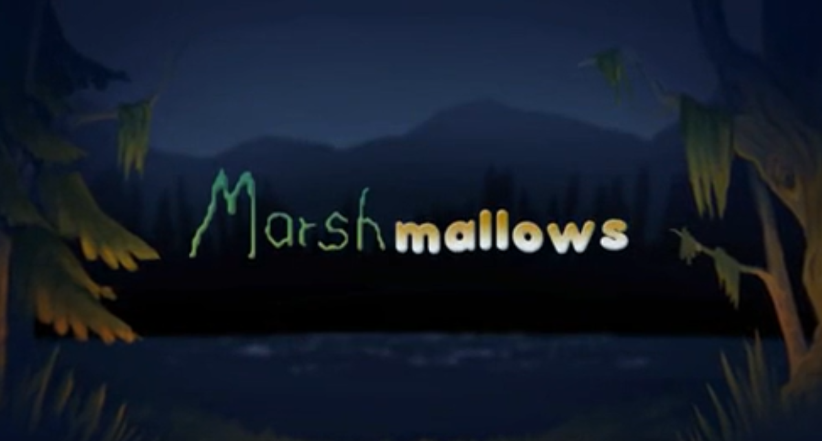

Tuesday 2nd February 2021

- How has your impression of the monster changed? Why?
My impression of the monster has changed because….

- How does the boy feel about the monster now?

- What do you think might happen next?

