
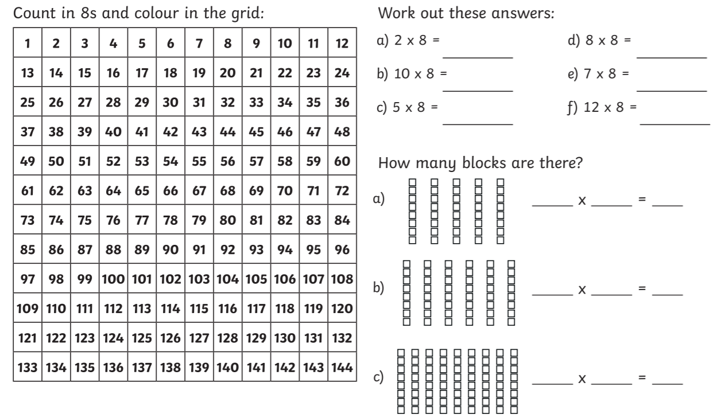
4.2.2021 L.O: Multiplication and Division C: Multiplying by 8

