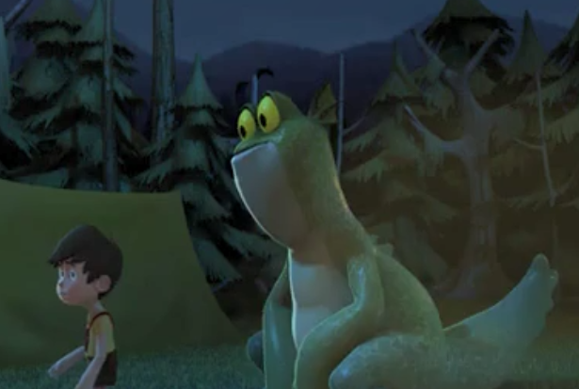
Thursday 3rd Guided Reading

What colour is the boys hair?

What colour are the monster’s eyes?

What does the boy do when the monster roars at him?

What does the boy throw, before he runs away, to get rid of the monster?

