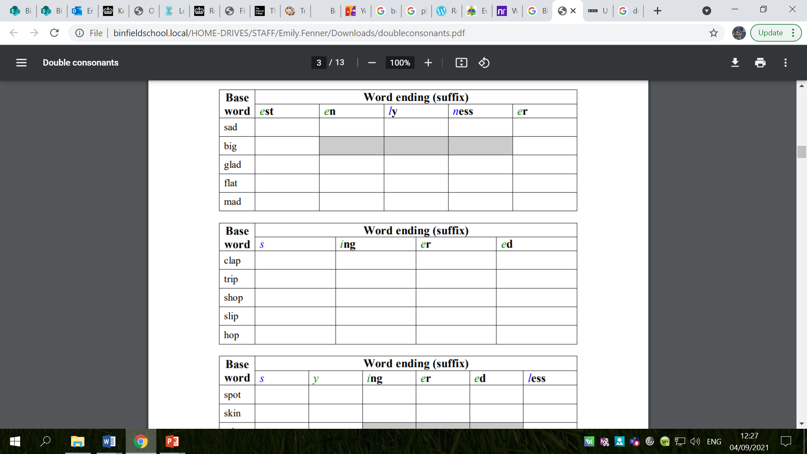
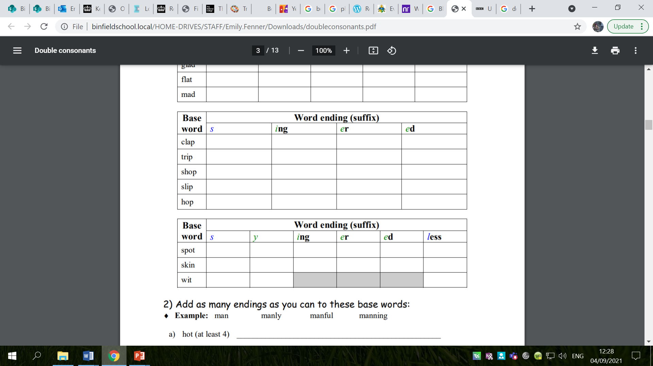
Complete the tables below:
Extension: Fill in the missing words. The root word is given in brackets but you need to add the correct ending.
1. My son is madly (mad) in love; he has gone shopping (shop) for some red roses!
2. The floor was _________ (spot). She had been _________ (scrub) it all morning.
3. Keep up your _________ (fit) by _________ (hop) and _________ (skip).
4. He _________ (skid) to a halt, having _________ (stop) too quickly at the red light.
5. It was a really _________ (star) night; the new moon was the _________(thin) crescent I had ever seen. I _________ (beg) him to come and look but he was too busy.
6. I _________(glad) accepted his offer of help. He _________ (fit) a new shelf in my kitchen. In return, I made him the _________ (big) chocolate cake you have ever seen!
7. The gymnast was the peak of _________ (fit). She _________ (flip) over into a handstand. In a fit of _________ (mad) I tried to copy her, but _________ (sad) I _______ (slip) and hurt my wrist. The ________ (red) has gone now but it still hurts.
8. The _________ (ship) of goods was late. I had to tell the impatient _________ (shop) to come back tomorrow. They were the _________ (mad) customers I have ever seen!

