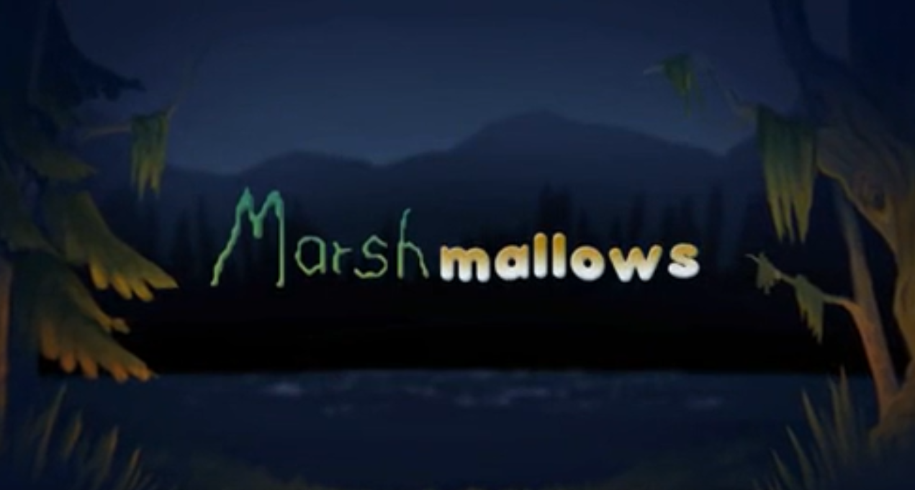

Monday 1st February 2021

- How is tension created in this film?

- What type of character do you think the monster is and why?

- How do you think the boy is feeling when he sees the monster? What clues are there?

