
5.2.2021 L.O: Multiplication and Division C: Divide by 8
Pirate Maths!
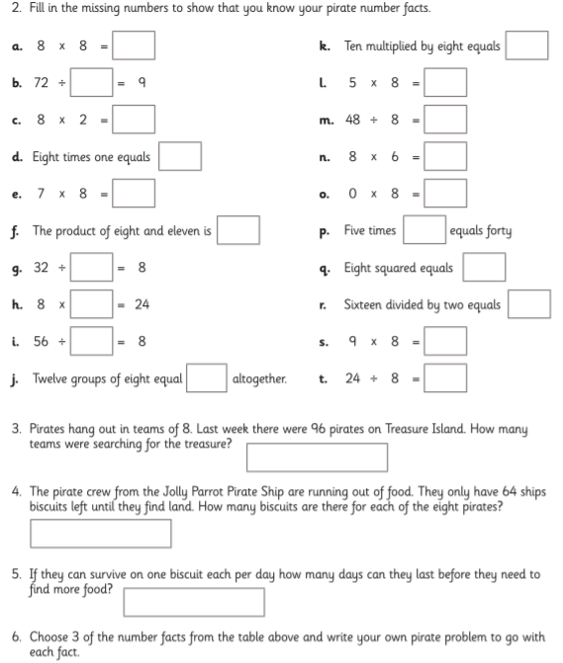
5.
4.
3.
2.
1.

