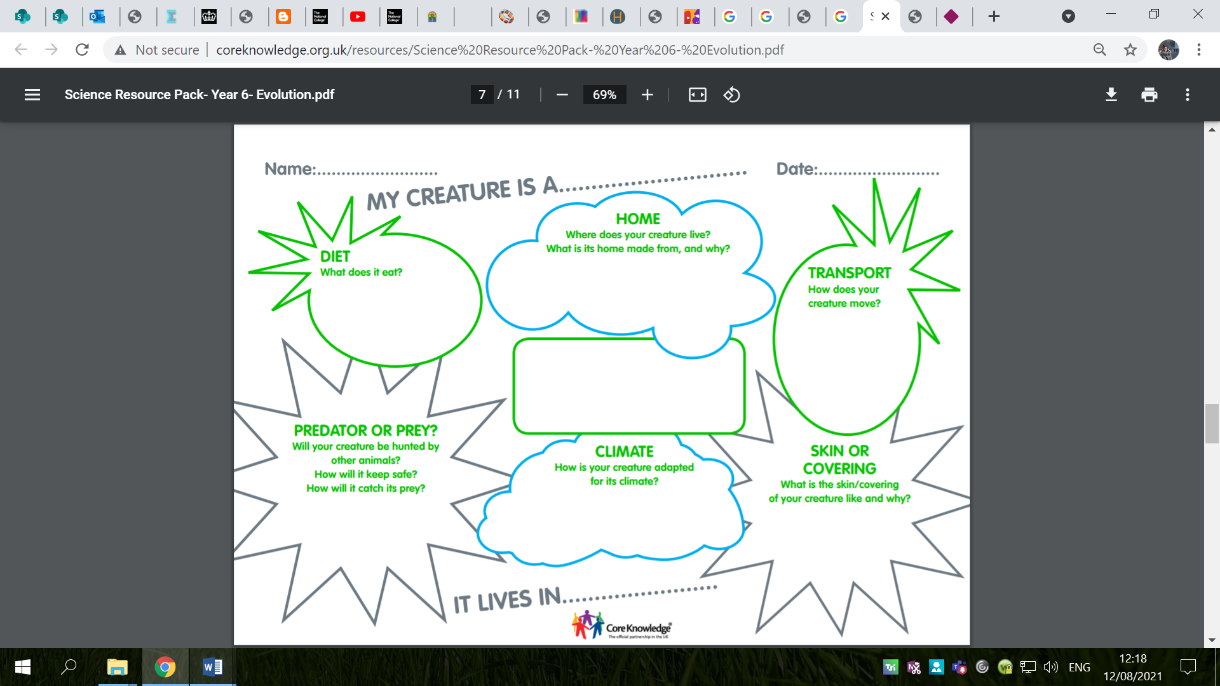
Social Behaviour:
Does your plant or animal live in a colony or group or is it solitary?
Protection:
Does it have any in built protection or deterrent to prevent being eaten?
Climate:
What characteristics does it have that help it to survive in its climate?
Shelter:
How is it designed to find or create shelter?
Movement:
What characteristics will it need to move successfully around its environment?
Food/Water:
What will it eat and drink?
How do its characteristics support this?
Predators/Prey:
How do its characteristics help it to elude predators or catch prey?
Food/Water:
What will it eat and drink? How do is characteristics support this?

