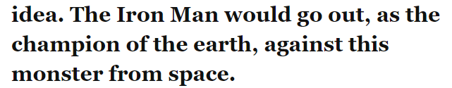
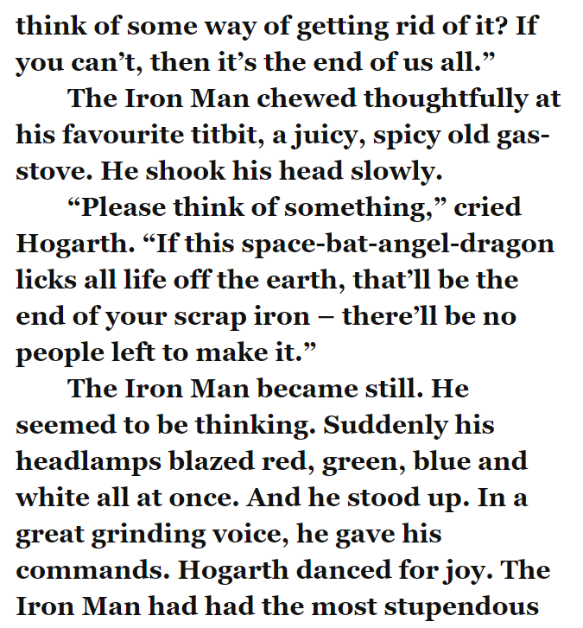
Today, we are going to be putting our select and retrieve skills to the test by answering the questions below.

- How does the author describe the gas-stove that the Iron Man ate through?

- What colour did the Iron Man’s eyes blaze?

- How is the Iron Man’s voice describes?

- How does the Iron Man describe the space-bat-angel-dragon?

Select and Retrieve

