1. Write speech/thought bubbles for the characters labelled A, B and C in the picture according to what you think is happening. (2 marks)

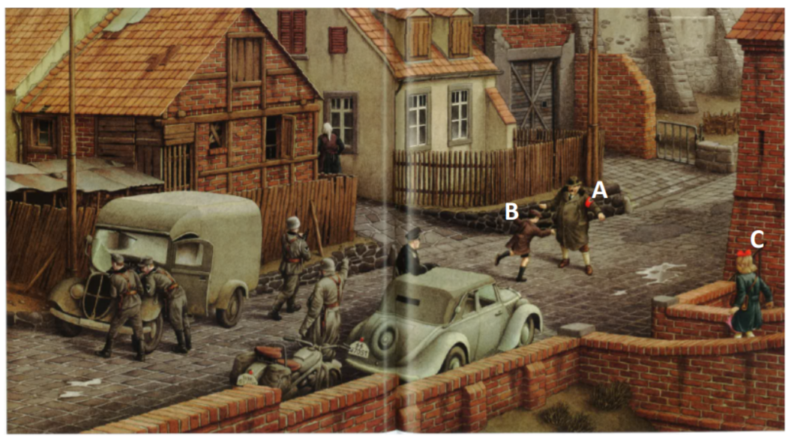

2. Compare and contrast how the 3 characters are feeling and why. Use the table to help with your explanation. Use evidence from the text. (3 marks).
 | Mayor | Boy | Rose
Feelings

