14.6.2021 L.O: To use fractions. C: Fractions on a number line.
1)
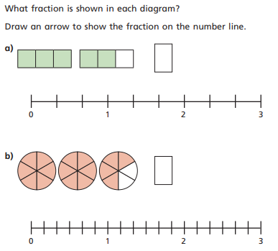
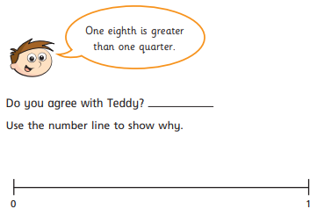
3)

2)
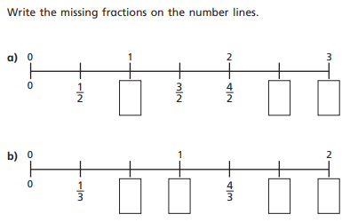

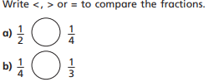
4)

