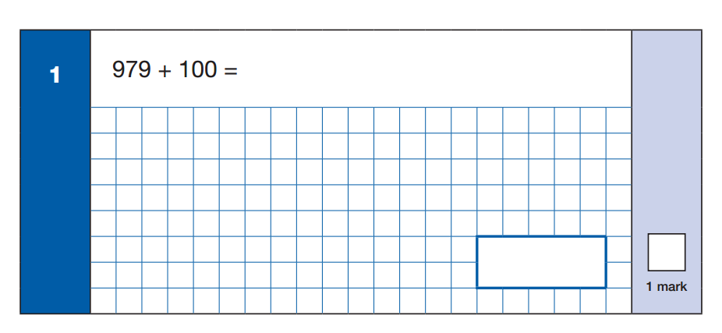
Fill in the missing numbers 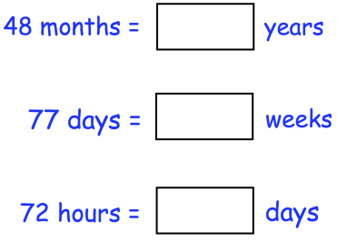
Starter
3
2
849 + 200
100 X 395
3
2
6.5 + 5.6 =
245x5 =
656+90 =
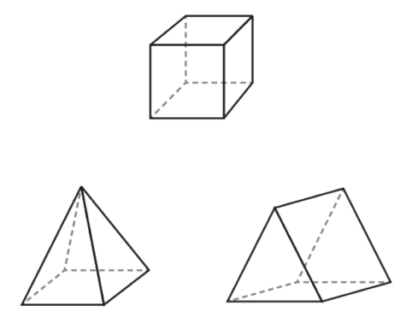

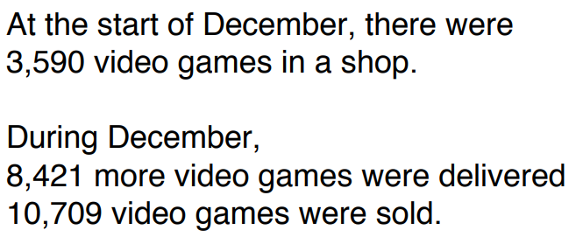
4
5


