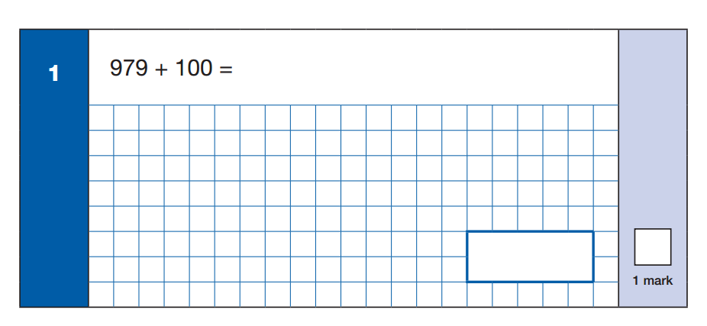
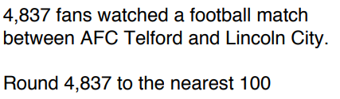
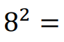
Starter
3
2
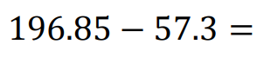
3
2
6.5 + 5.6 =
245x5 =
656+90 =
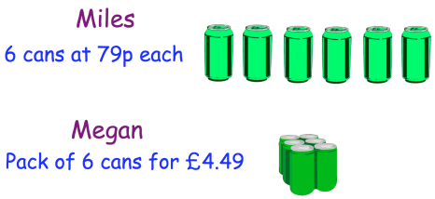
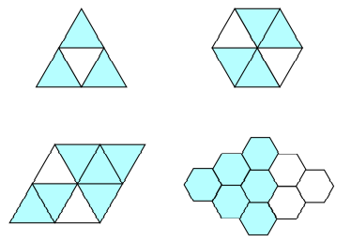
Miles and Megan both buy 6 cans of fizzy drinks. How much more money does Miles pay than Megan?
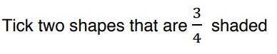
4
5

