
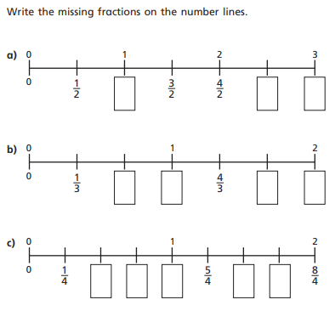
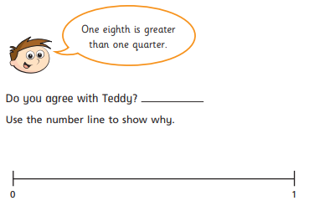
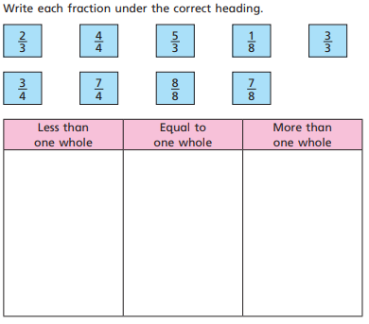
14.6.2021 L.O: To use fractions. C: Fractions on a number line.
2)
1)
3)

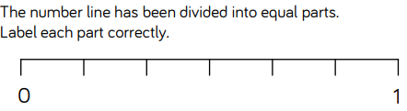
4)

