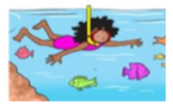
11.1.2021 L.O: Multiplication and Division C: Multiplication Equal Groups
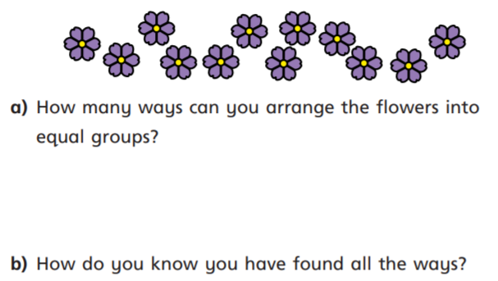
- In your book please answer the questions below. Please label each of your arrangements using the STEM sentence: There are ….. equal groups of ……

- In your book please can you draw a small and neat picture to show each of these…

- Four equal groups of three
- Three equal groups of four
- Six equal groups of two
- Two equal groups of eight

11.1.2021 L.O: Multiplication and Division C: Multiplication Equal Groups
- In your book please answer the questions below. Please label each of your arrangements using the STEM sentence: There are ….. equal groups of ……

- In your book please can you draw a small and neat picture to show each of these…

- Four equal groups of three
- Three equal groups of four
- Six equal groups of two
- Two equal groups of eight

