
11.1.2021 L.O: Multiplication and Division C: Multiplication Equal Groups
- Use a ruler to match up the picture to the correct label.
- In your book please can you write a sentence describing each picture. Use this STEM sentence to help you: There are ……. equal groups of …….
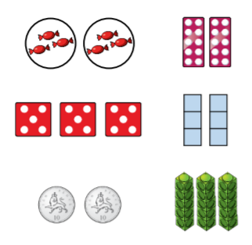
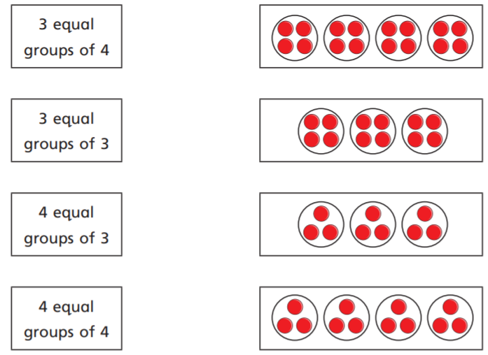
f)
e)
d)
c)
b)
a)

11.1.2021 L.O: Multiplication and Division C: Multiplication Equal Groups
- Use a ruler to match up the picture to the correct label.
- In your book please can you write a sentence describing each picture. Use this STEM sentence to help you: There are ……. equal groups of …….
f)
e)
d)
c)
b)
a)

