
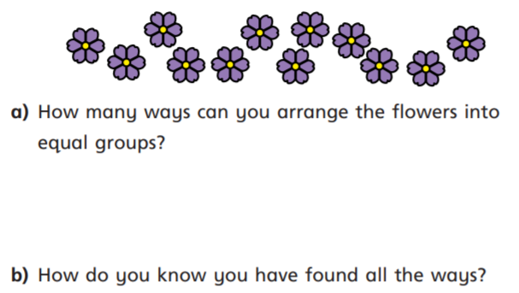
11.1.2021 L.O: Multiplication and Division C: Multiplication Equal Groups
1)In your book please answer the questions below. Please label each of your arrangements using the STEM sentence: There are ….. equal groups of ……
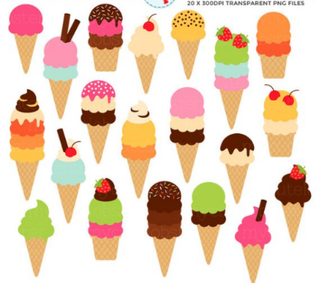
2) Can 20 ice creams be sorted into eight equal groups? Explain why/why not using pictures and clear explanations.

11.1.2021 L.O: Multiplication and Division C: Multiplication Equal Groups
1)In your book please answer the questions below. Please label each of your arrangements using the STEM sentence: There are ….. equal groups of ……
2) Can 20 ice creams be sorted into eight equal groups? Explain why/why not using pictures and clear explanations.

