Snorkelling
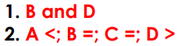

Diving
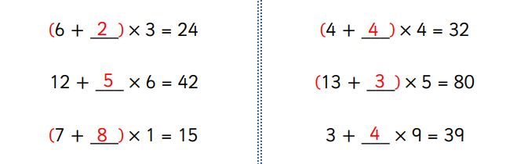
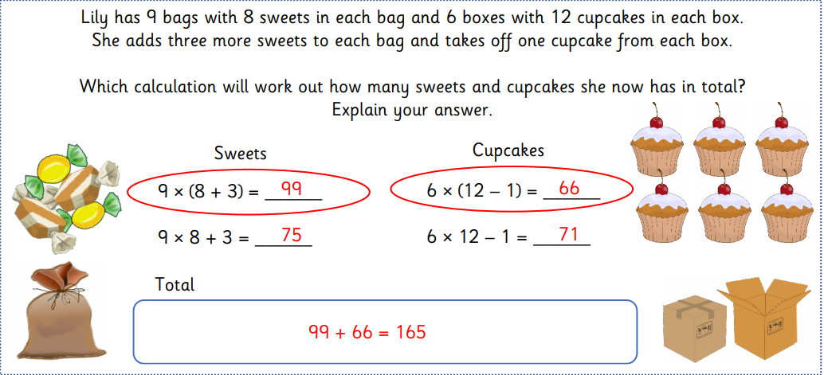

Extension



