Red Pen Question: Can you solve this in your books?
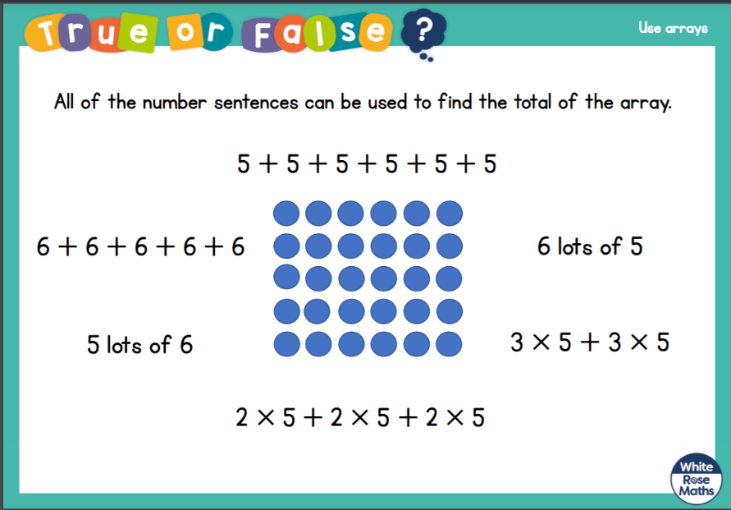
Make sure you are really clear and use mathematical language.

Red Pen Question: Can you solve this in your books?
Make sure you are really clear and use mathematical language.

