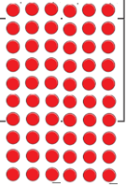

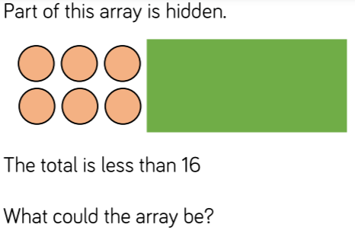

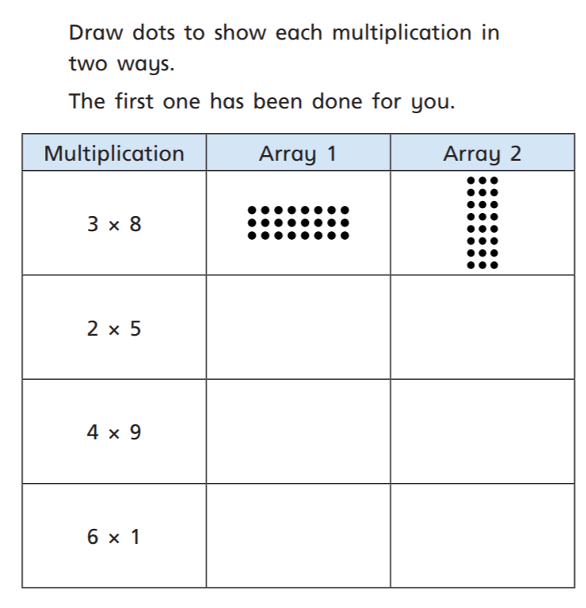
14.1.2021 L.O: Multiplication and Division C: Arrays
2)

1)



Multiple answers:
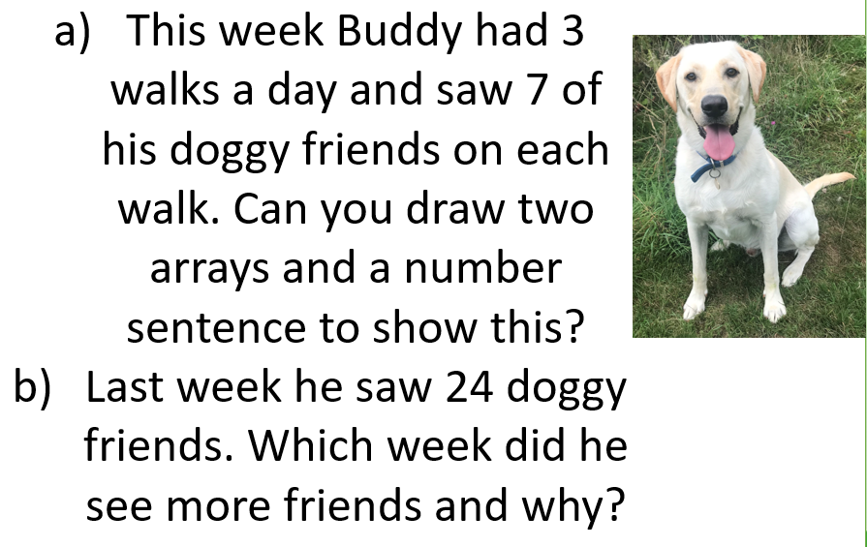
2 x 4, 2x5, 2x6, 2x7,
b) Buddy saw more doggy friends last week because he saw 21 this week and 24 last week.
3 x 7 =21

