
14.1.2021 L.O: Multiplication and Division C: Arrays
2)
In your book, can you draw arrays to show:
1)
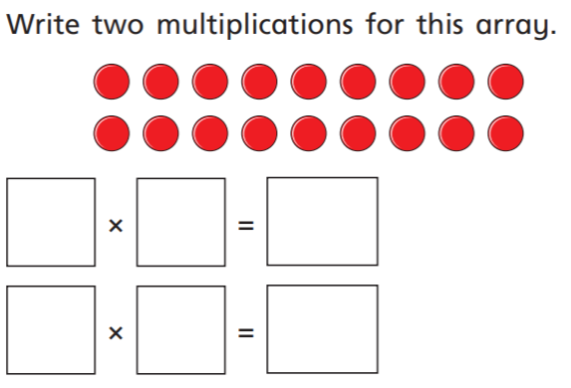
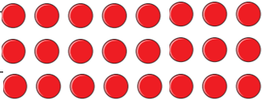
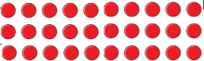
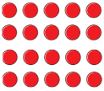
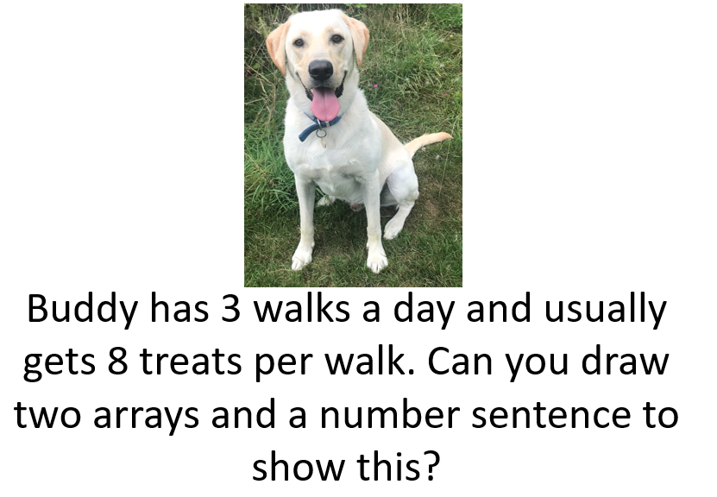
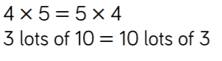
3 x 8 = 24
=
=
18
18
9
9
2
2

