Build a Cladogram
1. Begin by filling in the table.
Mark an X if the species has the trait and O if they do not.

2. Next, count how many times you chose ‘yes’ (X) for each characteristic.
Those characteristics with a large number of ‘yeses’ are more ancestral characteristics because they are shared by many.
Those traits with fewer ‘yeses’ are derived characters and have evolved later.
“Derived characters are advanced traits that only appear in some members of an evolutionary group.

3. Use these derived characters to build your cladogram on a diagonal line.
The derived character that is written first (nearest to the bottom) is the characteristic shared by most of the species. The species that does not share that characteristic is called an outgroup and will be the first branch on your cladogram.
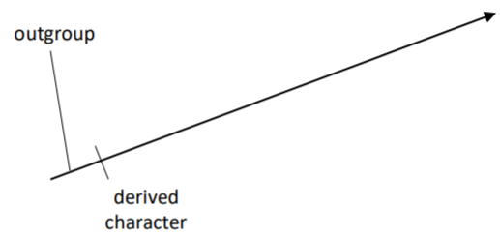

4. With the remaining species, choose the next outgroup and so on until every
species is represented on the cladogram.

