
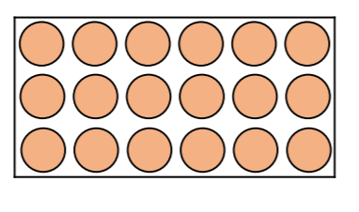
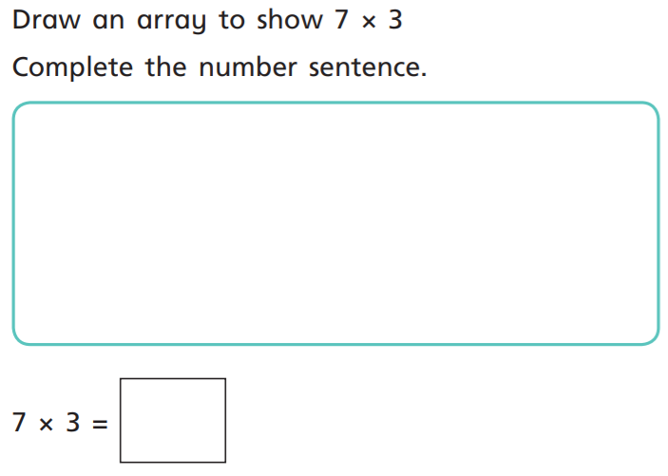
14.1.2021 L.O: Multiplication and Division C: Arrays
2)
Which multiplication(s) does this array show?
1)

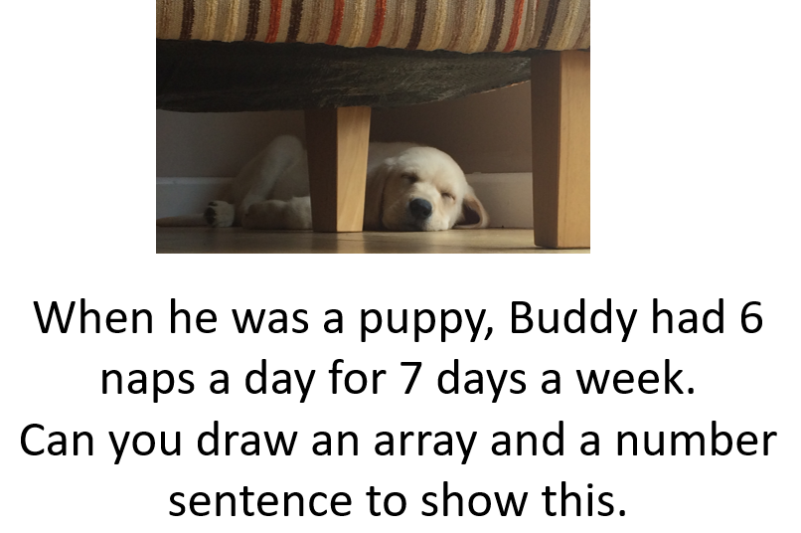

6 x 7 = 42
6 x 3 =18

