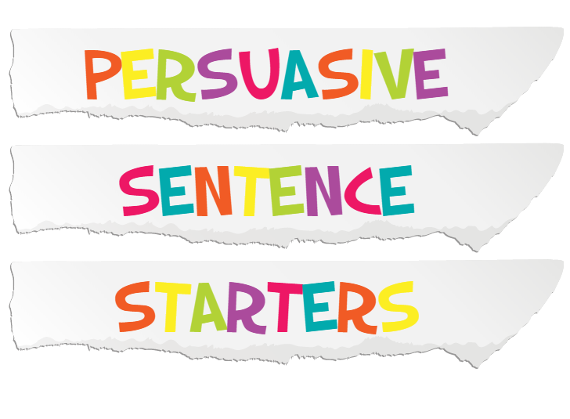

Rhetorical questions
- Is it any wonder that . . . ?
- Don’t you think . . . ?
- Isn’t it clear that . . . ?
- Isn’t it the case that . . . ?
- How can anyone believe this to be true?
- Does anyone really believe that . . .?

Phrases using that
- I believe that . . .
- I think that . . .
- It seems to me that . . .
- It is clear that . . .
- It strikes me that . . .
- There is no doubt that . . . (There can be no doubt that . . .)
- I am convinced that . . .
- It appears that . . .

It is obvious that . . .

Other phrases to start a sentence with
- In my opinion . . .
- As I see it . . .
- As everyone knows . . .
- Clearly . . .
- Obviously . . .
- Inevitably . . .
- My own view is . . .

Phrases to finish off with
- My last point is . . .
- My final point is . . .
- Finally,
- In conclusion,
- In summary,
- To conclude I would like to say . . .
- On the basis of the evidence presented . . .
- On balance . . .
- The evidence presented supports the view that . . .
- It is my sincere belief that . . .

Phrases to use when providing evidence
- For example,
- I cite, as an example . . .
- My evidence to support this is . . .
- I would draw your attention to . . .
- I would refer to . . .

Initial phrases followed by a comma
- Surely,
- Firstly,
- Secondly,
- Thirdly,
- In addition,
- Furthermore,
- Moreover,

