
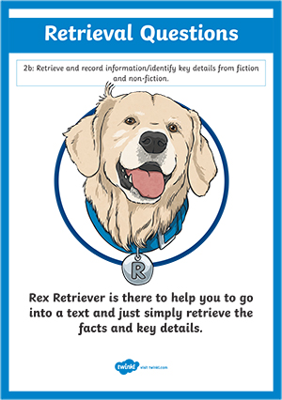
Monday 24th January 2022
L.O: To understand texts
C: The Iron Man- retrieval skills

- Where did the farmers dig the “deep, enormous hole.”? (1 mark)
- Find and copy two adjectives used to describe the hole. (2 marks)
- What three things did they cover the hole with? (2 marks)
- What did they put on “the side of the hole opposite the slope up to the top of the cliff”? (1 mark)
- Look at p.36. What machines were the farmers planning to use to bury the Iron Man? (2 marks)
- Look at p.37. Copy one phrase the show how the farmers were feeling on their way to check the trap. (1 mark)
- Look at p.38. What did the farmers wonder? (2 marks)
- Why didn’t the farmers want to fill in the hole? Give one reason. (1 mark)
Red Pen: What is your top tip for retrieval questions?

