
Thursday 27th January 2022
L.O: To use similes effectively.
C: Mystery Story
Task 1:
- Match the simile to the picture. Can you also write your own for each picture?
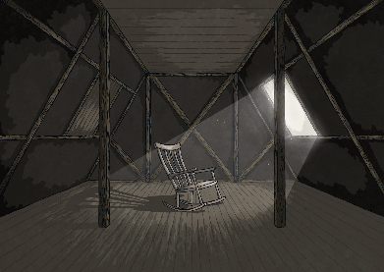
The trees were stood tall like regimented soldiers.

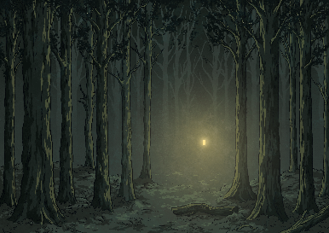
The chair was a lonely as a tumbleweed.

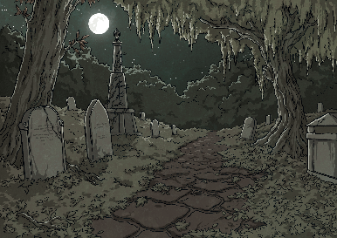
The path was cracked like eggshells.

Task 2:
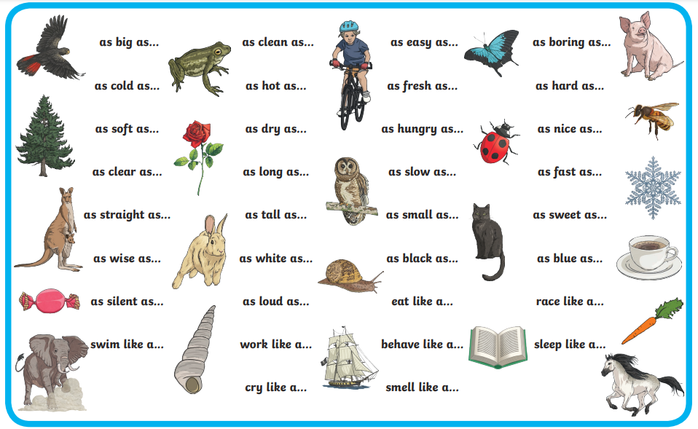
- Use the word mat to write three similes of your own to match your drawing of your scene.

