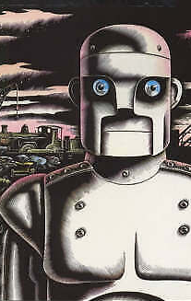
Tuesday 25th January 2022
L.O: To plan, write, edit and improve.
C: Mystery Story
Today we boxed-up our plans ready for our mystery story!
Structure | General | My story
Introduction | We meet the main characters and are introduced to the setting.  Everything seems normal… | - Characters: Year 3 children. They are kind, adventurous and good team players.  - Setting: Binfield Church of England Primary School
Build Up | The main character hears about something suspicious. They wonder what has happened and begin to ask questions… | - Everything seems normal until they receive a phone call from Mrs Brazell.  - They here about a dangerous incident in the BOLE.  - “What could have happened?”
Problem | The main character sees something mysterious! They react! | - The BOLE is full of rusty metal tools.  - The children are surprised and suspicious. They are horrified.
Resolution | The main character searches for clues to work out what has happened and why… | - The look closely at the tools and work with their friends.  - All the items have huge bite marks!  - The bite marks are too big to be squirrels.
Ending | The mystery is solved! | - The children realise it is the Iron Man!  - They warn the other children and teachers, to help keep everyone safe.

