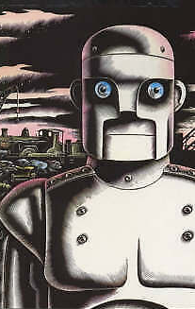
Tuesday 25th January 2022
L.O: To plan, write, edit and improve.
C: Mystery Story
Today we boxed-up our plans ready for our mystery story!
Structure | General | My story
Introduction | We meet the main characters and are introduced to the setting.  Everything seems normal…
Build Up | The main character hears about something suspicious. They wonder what has happened and begin to ask questions…
Problem | The main character sees something mysterious! They react!
Resolution | The main character searches for clues to work out what has happened and why…
Ending | The mystery is solved!

