Date:
LO: To use ‘ask and answer input block’ in a variable block.
C: Maths questions

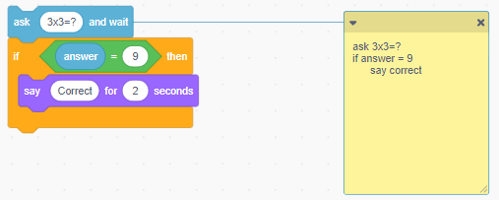
- Match the types of condition to the examples below.
Condition stops the action

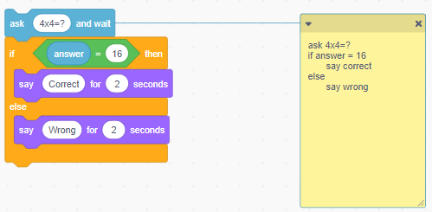
Condition switches between the actions
Condition starts the action

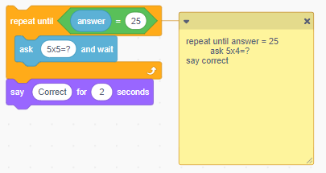

- Look at the codes above. In the green boxes there is an = sign. What does this symbol mean?

- Look at the code below. What will happen if I put in the wrong answer?

  - What will happen if I put in the answer 24?

- Look at the code below.
        - What will I do if I have short hair?

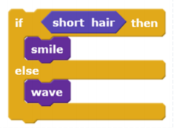
        - What will I do if I have long hair?

        - What is the ‘condition’ in the code?

