
22.2.2021 L.O: Multiplication and Division
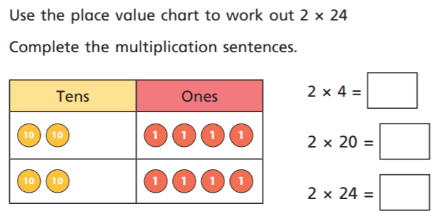
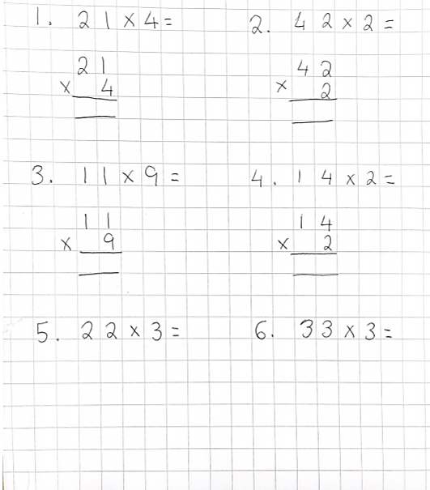
C: Multiply 2-digits by 1-digit – no exchange
Watch the video then try and solve these multiplication equations!

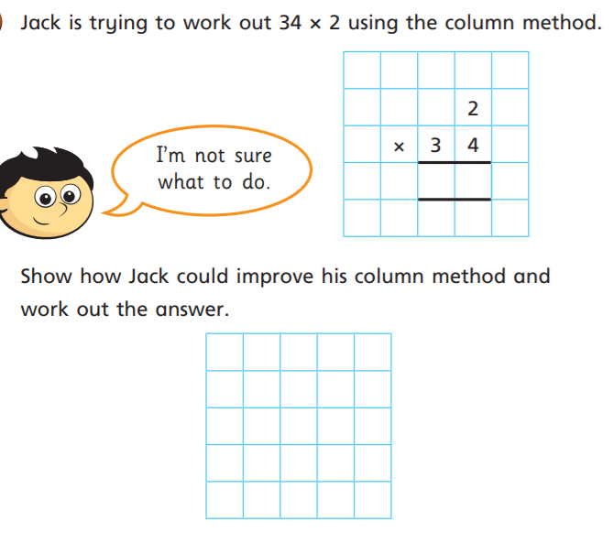
2)

