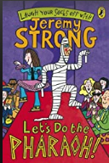
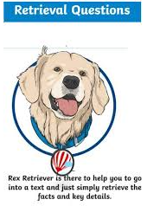
Monday 6th September 2021
PADDLERS AND SNORKELLERS
L.O: To skim and scan, C: Let’s do the Pharaoh!
I worked: Independently/with a teacher/with a TA
- Pick three words or phrases which are used to describe Grimstone
- Pick three words or phrases which are used to describe Professor Jelly
- Why did Pharaoh collapse outside the ice-cream van?
- What happened to Jelly and Grimstone when they tried to force the secret of the treasure map out of Sennapod?
Monday 6th September 2021
PADDLERS AND SNORKELLERS
L.O: To skim and scan, C: Let’s do the Pharaoh!
I worked: Independently/with a teacher/with a TA
- Pick three words or phrases which are used to describe Grimstone
- Pick three words or phrases which are used to describe Professor Jelly
- Why did Pharaoh collapse outside the ice-cream van?
- What happened to Jelly and Grimstone when they tried to force the secret of the treasure map out of Sennapod?

Monday 6th September 2021
PADDLERS AND SNORKELLERS
L.O: To skim and scan, C: Let’s do the Pharaoh!
I worked: Independently/with a teacher/with a TA
- Pick three words or phrases which are used to describe Grimstone
- Pick three words or phrases which are used to describe Professor Jelly
- Why did Pharaoh collapse outside the ice-cream van?
- What happened to Jelly and Grimstone when they tried to force the secret of the treasure map out of Sennapod?

