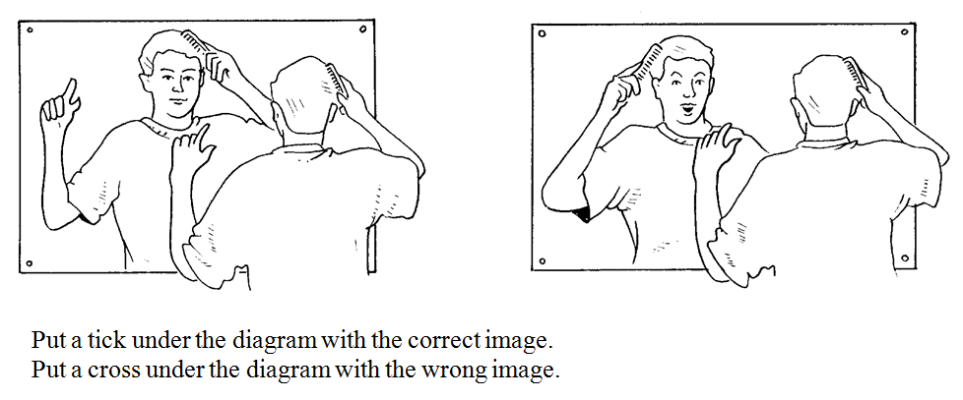
In your book, describe what you see when you look into a mirror.

In your book, describe what you see when you look into a mirror

Crumpled foil, smooth foil, card, plastic bag, mirror, spoon
Object | Is it a good reflector? |  | What do you notice?
Object | Yes | No | What do you notice?
e.g. foil | √ |  | It’s smooth and shiny
What was the best reflector?
__________________________________________________________________________________
Why do you think it was the best?
__________________________________________________________________________________
__________________________________________________________________________________
__________________________________________________________________________________
Crumpled foil, smooth foil, card, plastic bag, mirror, spoon
Object | Is it a good reflector? |  | What do you notice?
Object | Yes | No | What do you notice?
e.g. foil | √ |  | It’s smooth and shiny
What was the best reflector?
__________________________________________________________________________________
Why do you think it was the best?
__________________________________________________________________________________
__________________________________________________________________________________
__________________________________________________________________________________

Can you write your name in the box below so it can be read in a mirror if you put a mirror on the line?
Handy hint: Practise on a whiteboard- this is trickier than it looks!

Can you write your name in the box below so it can be read in a mirror if you put a mirror on the line?
Handy hint: Practise on a whiteboard- this is trickier than it looks!

