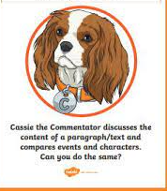
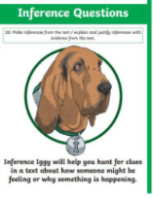
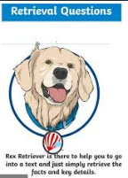
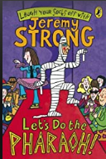
Monday 27th September 2021
LO: NFER style questions.
C: Let’s do the Pharaoh

- Read paragraph 1, page 89. Find and copy a word that suggests Carrie is upset. (1 mark)
- Read paragraph 3, page 89. How is Crusher of Worms feeling? How do you know (2 marks)
- Look at the picture on page 90. “He reached down, grabbed her by the arm and hauled her to her feet.” How does Carrie and Ben’s relationship differ to the start of the story? (2 marks)

Monday 27th September 2021
LO: NFER style questions.
C: Let’s do the Pharaoh

- Read paragraph 1, page 89. Find and copy a word that suggests Carrie is upset. (1 mark)
- Read paragraph 3, page 89. How is Crusher of Worms feeling? How do you know (2 marks)
- Look at the picture on page 90. “He reached down, grabbed her by the arm and hauled her to her feet.” How does Carrie and Ben’s relationship differ to the start of the story? (2 marks)

Monday 27th September 2021
LO: NFER style questions.
C: Let’s do the Pharaoh

- Read paragraph 1, page 89. Find and copy a word that suggests Carrie is upset. (1 mark)
- Read paragraph 3, page 89. How is Crusher of Worms feeling? How do you know (2 marks)
- Look at the picture on page 90. “He reached down, grabbed her by the arm and hauled her to her feet.” How does Carrie and Ben’s relationship differ to the start of the story? (2 marks)

