
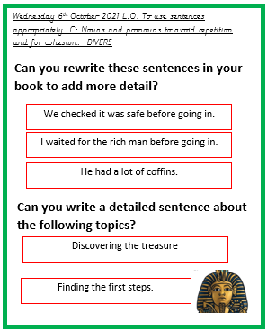
Wednesday 6th October 2021 L.O: To use sentences appropriately. C: Nouns and pronouns to avoid repetition and for cohesion. DIVERS

Can you rewrite these sentences in your book to add more detail?
We checked it was safe before going in.
I waited for the rich man before going in.
He had a lot of coffins.
Discovering the treasure
Finding the first steps.
Can you write a detailed sentence about the following topics?

