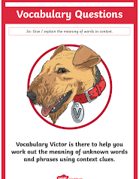

Monday 4th October 2021
LO: To understand texts.
C: Let’s do the Pharaoh (Vocabulary)
Today in the BOLE we had a vocabulary hunt! Here are my definitions:
paramedic
“a paramedic called to them”
sacred
“Sennapod was not going to utter his real name. That was sacred”
tranquillizer
“I shall have to inject you with tranquillizer”
unceremoniously
“Sennapod was bundled unceremoniously into the ambulance”
pondered
“’Where do you think they’ll take him?’ pondered Ben.”

Red Pen Question: Can you write a sentence using one of the new words?

