4/10/2012
LO: To use addition and subtraction
C: Adding and subtracting multiples of 100

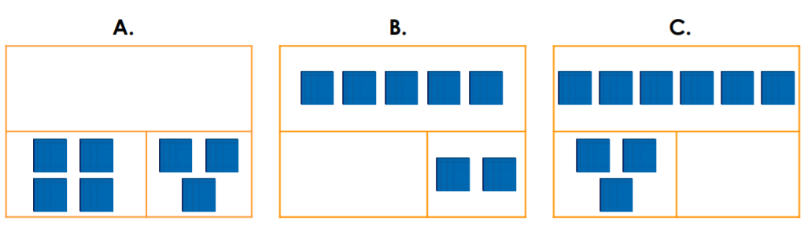
- Draw base 10 to complete the bar models.

- Write the four calculations shown in bar model A.
+ =

+ + =

- =

- =

- Complete the part-whole models


