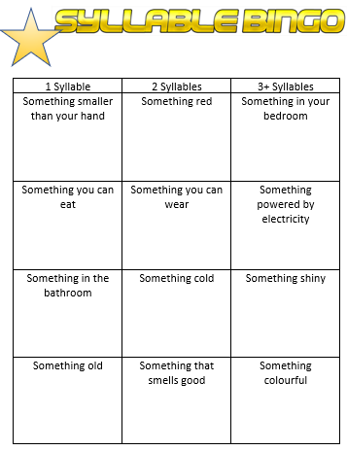


1 Syllable | 2 Syllables | 3+ Syllables
Something smaller than your hand | Something red | Something in your bedroom
Something you can eat | Something you can wear | Something powered by electricity
Something in the bathroom | Something cold | Something shiny
Something old | Something that smells good | Something colourful

