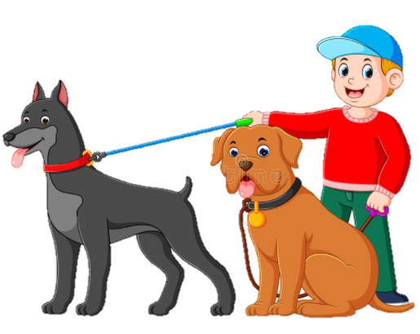


Option 3:
Big Dogs
Furry, friendly
Barking, fetching, playing
Always there to play fetch with you
My pets
Option 2:
Nature
Beautiful, green
Refreshing, relaxing
Nature is very important
Outside
Option 1:
Dino
Enormous, fierce
Roaming, fighting, screeching,
Sadly, dinosaurs are extinct,
Reptiles

