
23.2.2021 L.O: Multiplication and Division
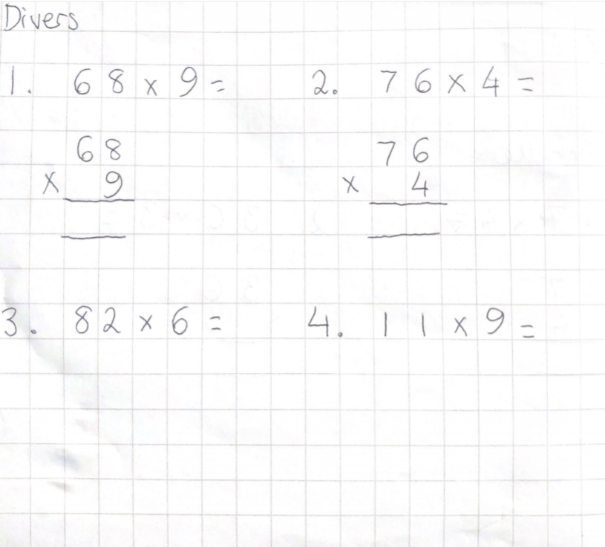
C: Multiply 2-digits by 1-digit – with exchange

