
24.11.2021
L.O: To use addition and subtraction
C: Subtract a 2 digit number from
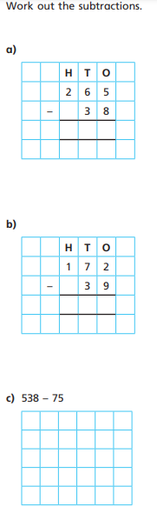
a 3 digit number – crossing 10 or 100
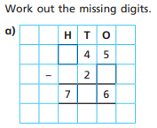

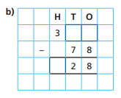
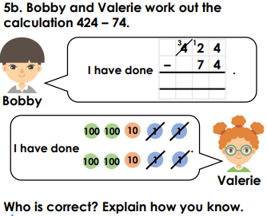
RED PEN: Please write an answer to the question below in your books.

