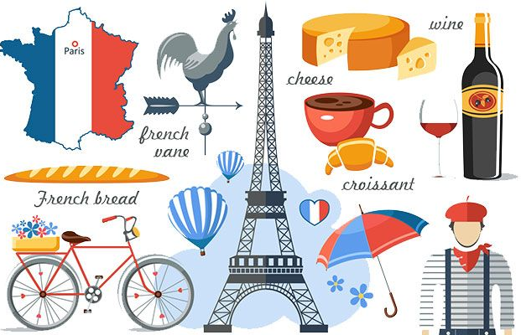
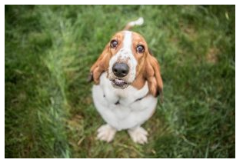

Can you draw your own dog and write a sentence to describe it?

________________________________________________________________________________________________________________________________________________________________________________________________________________

Red Pen:

Buddy est blanc, méchant et gentil. Can you translate my sentence?

_____________________________________________________________________________________________________________________________________________________________________________________________________________________________________________________________________

Culture:

In France, one of the most popular species are basset hounds!

Mardi 8 Mars 2022

Ton chien est comment?

