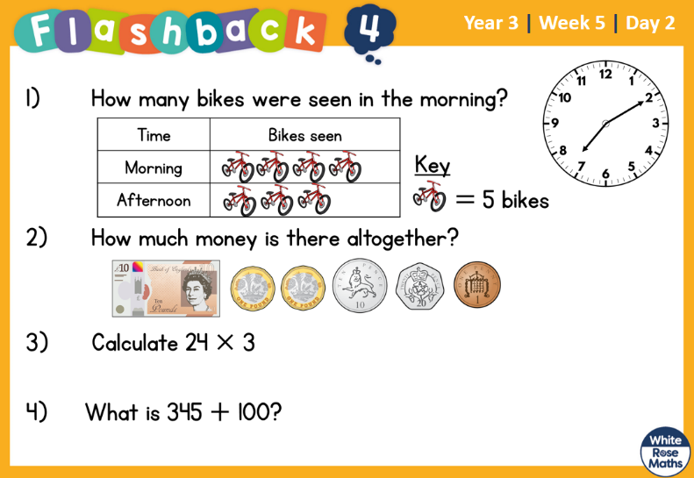
5.3.2022 L.O: To use statistics. C: To interpret pictograms.

5.3.2022 L.O: To use statistics. C: To interpret pictograms.

5.3.2022 L.O: To use statistics. C: To interpret pictograms.

