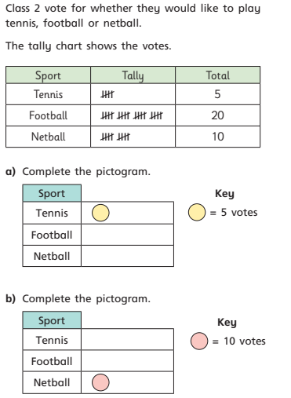

If the symbol shown represents 2, how could I represent:
- 1

- 5

- 11


