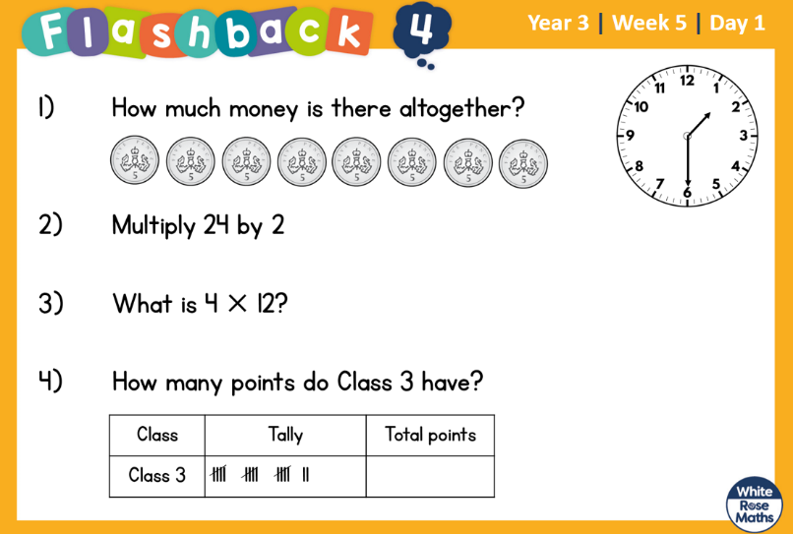
9.3.2022 L.O: To use statistics. C: Draw Pictograms
In your book, make a pictogram to represent one of our tally charts from yesterday.

9.3.2022 L.O: To use statistics. C: Draw Pictograms
In your book, make a pictogram to represent one of our tally charts from yesterday.

9.3.2022 L.O: To use statistics. C: Draw Pictograms
In your book, make a pictogram to represent one of our tally charts from yesterday.

