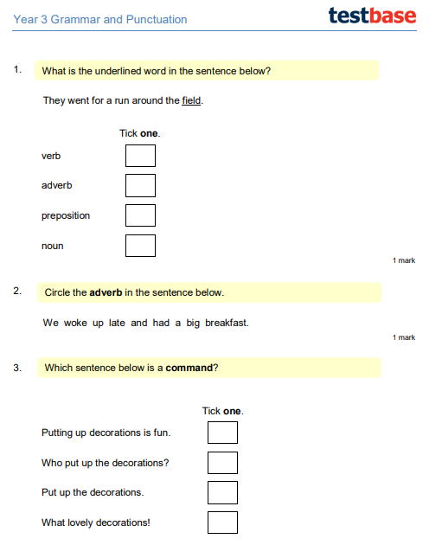
Monday 7th March 2022
LO: To plan, write and edit
C: News Report
Monday 7th March 2022
LO: To plan, write and edit
C: News Report

