Friday 14th January 2022
L.O: Understand movement, forces and magnets
C: Working Scientifically

Friction
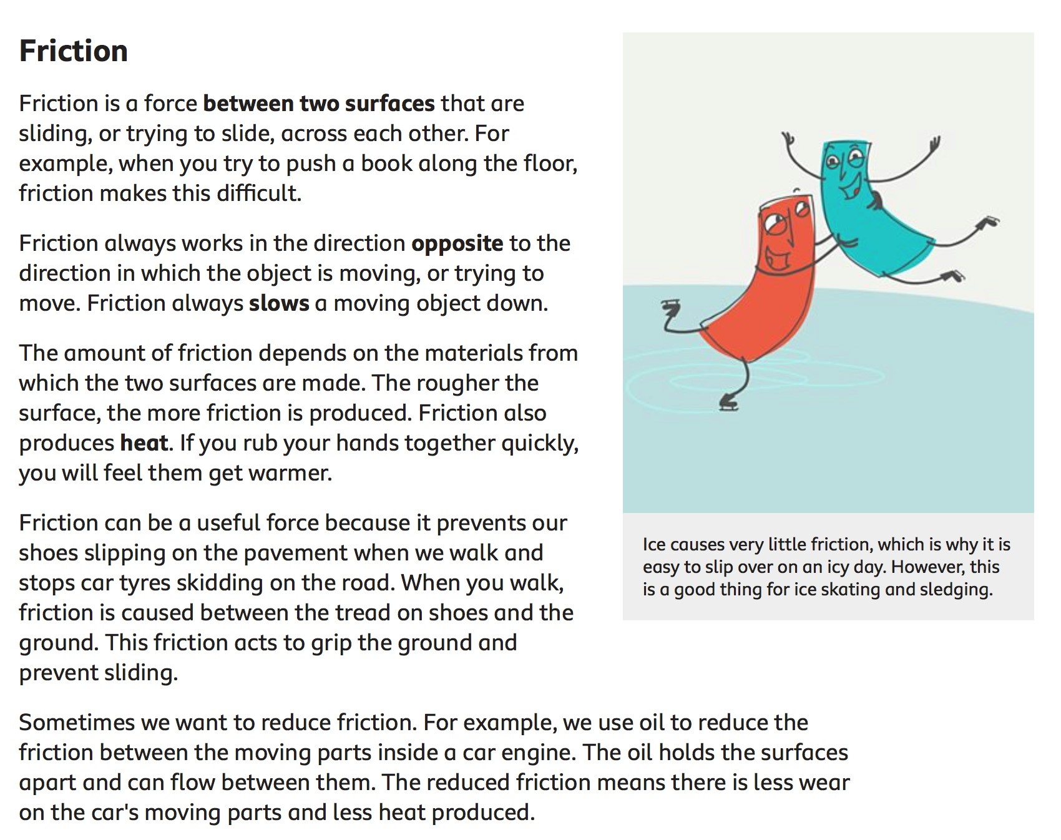

Science experiment to explore friction.

What you need
- A step, stack of books or lunch box to make a height to lean the ramps on.
- Something to make a ramp! Can be: cardboard, wooden plank, flat piece of plastic.
- Some different textures to stick to the ramp surfaces to create different friction, use your imagination here, all you want is a difference in texture and friction between the ramps.
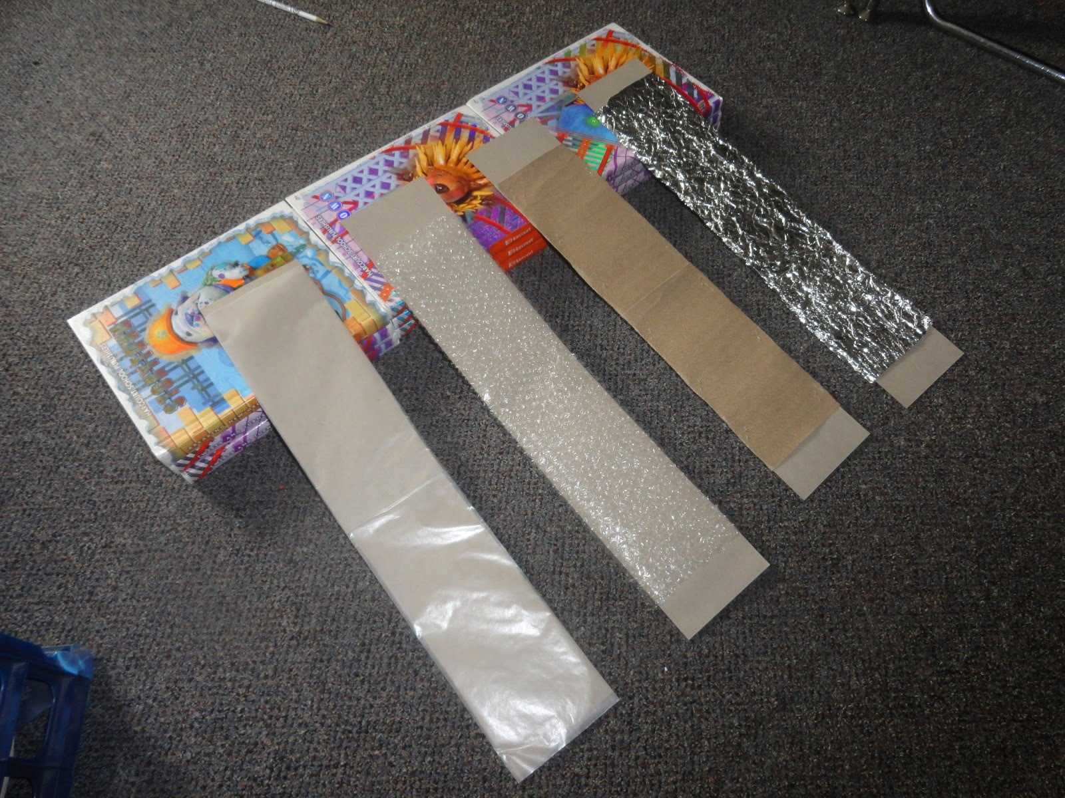
- Handtowel/Clothes/J-cloth o Sandpaper o Rubber grippy mats o Tinfoil
- Corrugated cardboard o Strips of velcro
- Tape to secure your friction surface o Toy cars!

• Stopwatch and measuring tape or ruler.

What to do
Set up
The set up for this activity is to have ramps at the same height and angles but with different textures! This allows exploration of how different textures produce different amounts of friction and therefore alter how easily objects move down the ramps.
Activity
- Free exploration: Start with exploring the control ramp with different cars. Which toy cars move faster or slower? Heavier, lighter, longer or shorter cars move at different speeds. You could also get them to put something else on the ramp, like a block, how does it move down the ramp?
- Move on to the texture’s ramps –feel the textures and describe them. Introduce the word friction here to link it to the different textures.
- Experiment time! Test the cars on the different textured ramps. What ramp do the cars move fastest on? What ramp does the car move slowest on? Discuss the results.
- Use a measuring tape to show how far the car travels after it leaves the ramp to see how fast it is going and then record the results. Put your results on the graph.

Stay Safe
- • Be careful if using heavy wood for ramp
- • Be careful with children standing on ramps or knocking over objects

Distance in cm
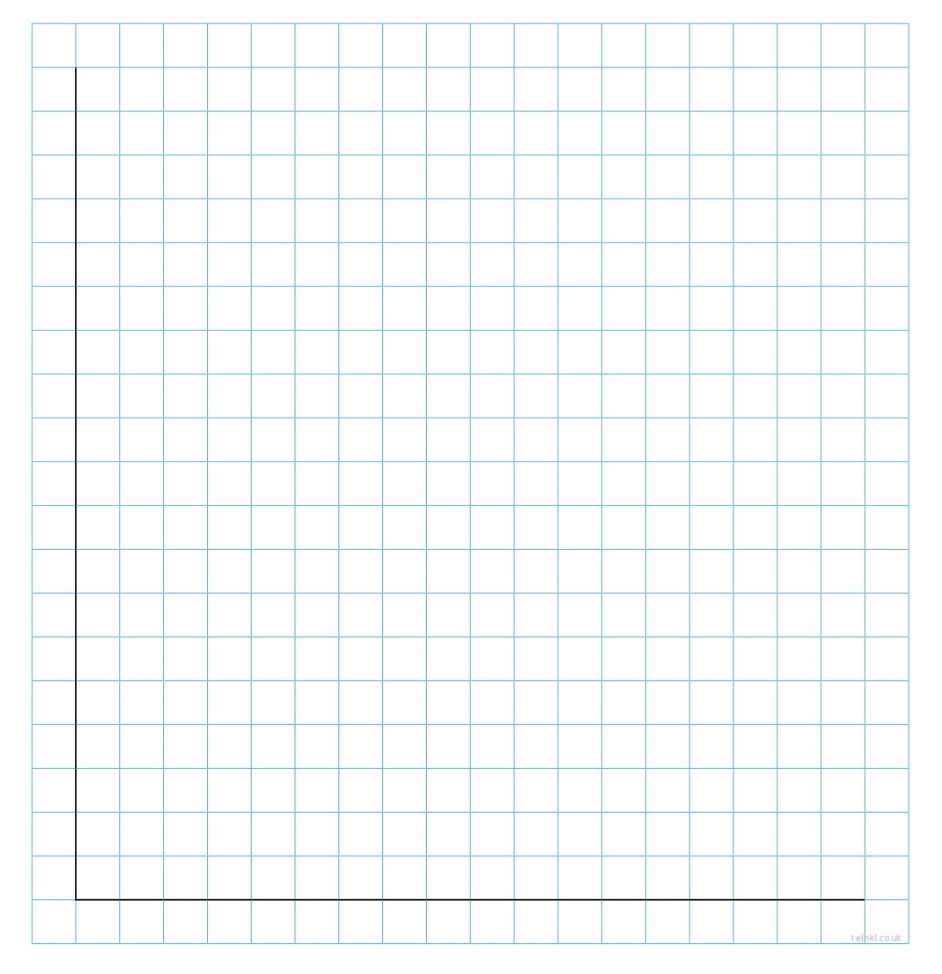
Type of material on ramp.

