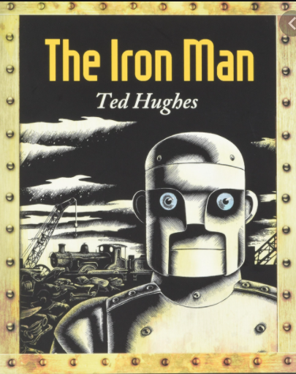
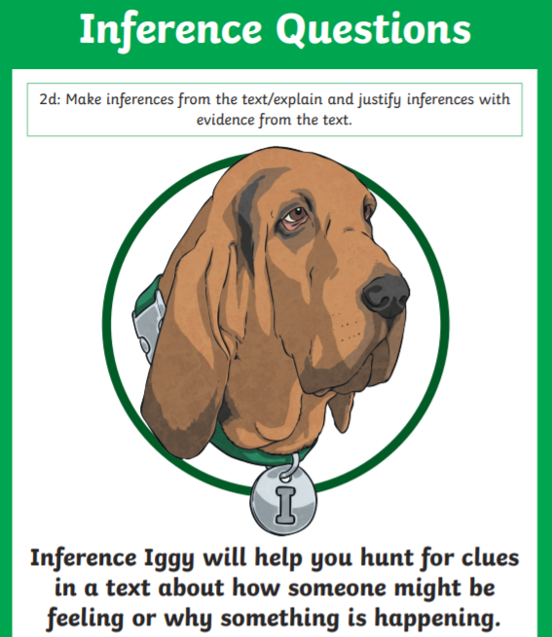
Monday 10th January 2022
L.O: To infer the reasons behind a character’s actions.
C: The Iron Man Paddlers
- Why do you think the Iron Man’s his eyes glowed red?
- Why do you think the Iron Man went off the cliff?
- Why did the Iron Man smash?

Monday 10th January 2022
L.O: To infer the reasons behind a character’s actions.
C: The Iron Man Paddlers
- Why do you think the Iron Man’s his eyes glowed red?
- Why do you think the Iron Man went off the cliff?
- Why did the Iron Man smash?

Monday 10th January 2022
L.O: To infer the reasons behind a character’s actions.
C: The Iron Man Paddlers
- Why do you think the Iron Man’s his eyes glowed red?
- Why do you think the Iron Man went off the cliff?
- Why did the Iron Man smash?

Monday 10th January 2022
L.O: To infer the reasons behind a character’s actions.
C: The Iron Man Paddlers
- Why do you think the Iron Man’s his eyes glowed red?
- Why do you think the Iron Man went off the cliff?
- Why did the Iron Man smash?

Monday 10th January 2022
L.O: To infer the reasons behind a character’s actions.
C: The Iron Man Paddlers
- Why do you think the Iron Man’s his eyes glowed red?
- Why do you think the Iron Man went off the cliff?
- Why did the Iron Man smash?

