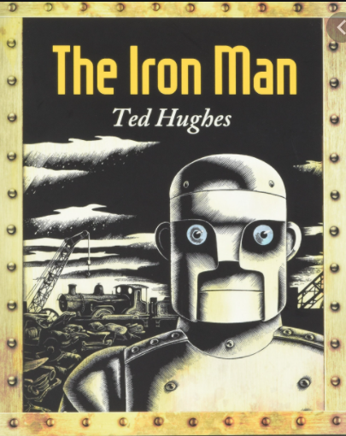
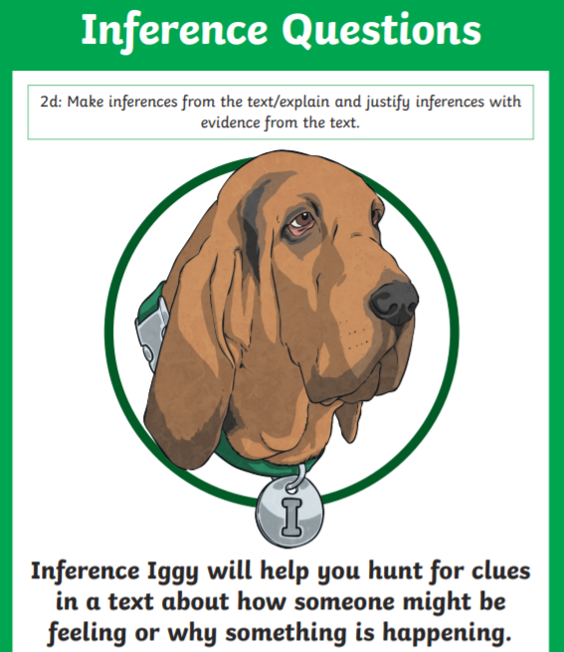
Monday 10th January 2022
L.O: To infer the reasons behind a character’s actions.
C: The Iron Man Divers
- Why do you think the Iron Man’s his eyes glowed red? Use evidence from the text.
- Why do you think the Iron Man went off the cliff? Give two possible reasons using evidence from the text. RED PEN: Which of your two ideas is the most likely reason and why?
- Why did the Iron Man smash?

Monday 10th January 2022
L.O: To infer the reasons behind a character’s actions.
C: The Iron Man Divers
- Why do you think the Iron Man’s his eyes glowed red? Use evidence from the text.
- Why do you think the Iron Man went off the cliff? Give two possible reasons using evidence from the text. RED PEN: Which of your two ideas is the most likely reason and why?
- Why did the Iron Man smash?

Monday 10th January 2022
L.O: To infer the reasons behind a character’s actions.
C: The Iron Man Divers
- Why do you think the Iron Man’s his eyes glowed red? Use evidence from the text.
- Why do you think the Iron Man went off the cliff? Give two possible reasons using evidence from the text. RED PEN: Which of your two ideas is the most likely reason and why?
- Why did the Iron Man smash?

