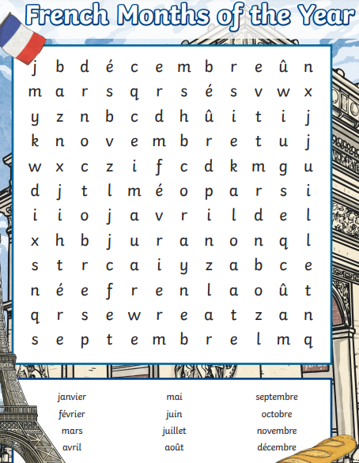
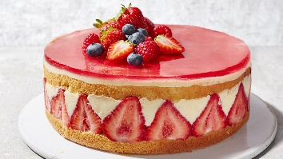
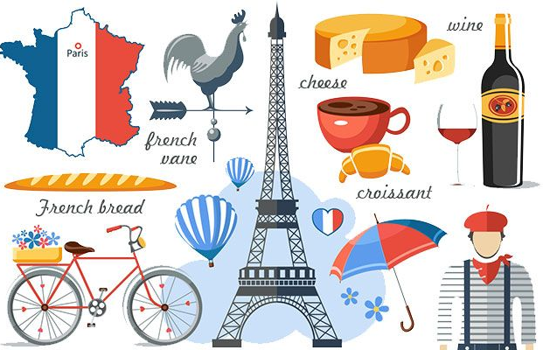

Red Pen:

Quelle est ta date d'anniversaire ?

____________________________________________________________________________________________________________

Culture:

In France, they still sing Happy Birthday- Joyeux Anniversaire. Also, they often have a fruit tart instead of a birthday cake!

Mercredi 9 Février 2022

Les Mois and Des Anniversaires

